# Design Overview for <<"Undead Pursuit: The Rescue of Damien Lee">>

Name: JOSHUA SANJAY KING

Student ID: 105282612 /J23039507

# Summary of Program

"Undead Pursuit: The hero of Damien Lee" is a 2D survival horror game where the player navigates through a zombie-infested city and defeat the final boss, Mr.Mushroom.

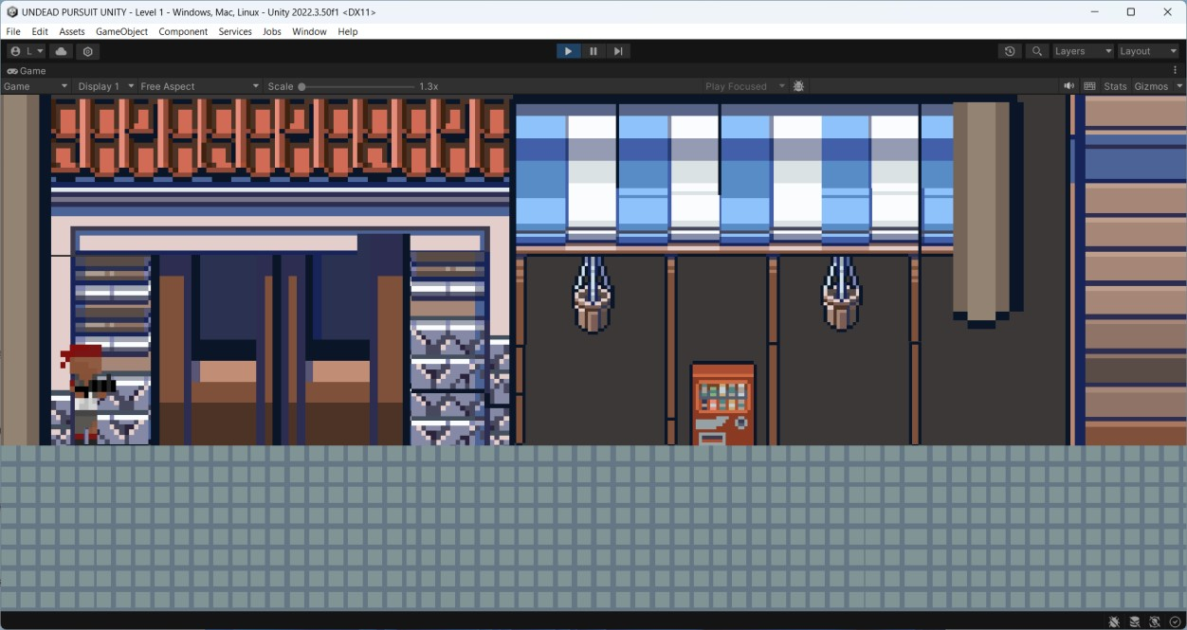

# Required Roles

Describe each of the classes, interfaces, and any enumerations you will create. Use a different table to describe each role you will have, using the following table templates.

*Table 1:* class *details*

|  |  |  |  |
| --- | --- | --- | --- |
| **Class name** | **Purpose** | **Properties** | **Method** |
| **Shooter** | Abstract base class to define common shooting behavior. | attackCooldown, firePoint, bullet | Awake(), Update(), Attack() |
| **PlayerShoot** | Inherits from Shooter and implements shooting mechanics specific to the player. | playerMovement | Awake(), Update(), Attack() |
| **CharacterMoveme**  **nt** | Base class for movement behaviors (jump, move, flip). | speed, body, originalScale, grounded, anim | Move(), Jump(),  FlipDirection(),  OnCollisionEnter2D() |
| **PlayerMovement** | Inherits from  CharacterMovement  for specific player movement behaviors like attack conditions. | horizontalInput | Awake(), Update(), CanAttack() |
| **CameraControl** | Manages the movement and  positioning of the camera, ensuring smooth transitions between rooms as the player moves. | speed (float) - Controls how quickly the camera moves. currentPosX  (float) - The target X-position of the camera.  velocity (Vector3) - Helps achieve smooth  transitions between positions. | Update() - Smoothly moves the camera toward the target position.  MoveToNewRoom(Transfor m _newRoom) - Updates the target position of the camera to center it on a new room’s position when transitioning. |
| **CameraDoor** | Detects when the player enters a "door" area between rooms and updates the CameraControl to move to the appropriate room based on the player’s position. | previousRoom  (Transform) - The previous room to switch to if the player is moving backward. nextRoom  (Transform) - The next room to switch to if the player is moving forward.  cam  (CameraControl) -  Reference to the CameraControl instance to control camera movement. | OnTriggerEnter2D(Collider2 D collision) - Detects the player entering the door trigger. Calls  cam.MoveToNewRoom() with nextRoom or previousRoom based on the player’s direction. |

*Table 2: role table details*

|  |  |  |
| --- | --- | --- |
| **Role Name** | **Purpose** | **Responsibilities** |
| **Player Controller** | Manages player actions and state (movement, shooting) | Implements shooting and movement; calls  appropriate animations and responses |
| **Enemy Controller** | Manages enemy behaviours (roam,attack) | Implement AI logic for detecting and engaging player, movement, and attack |

# Class Diagram

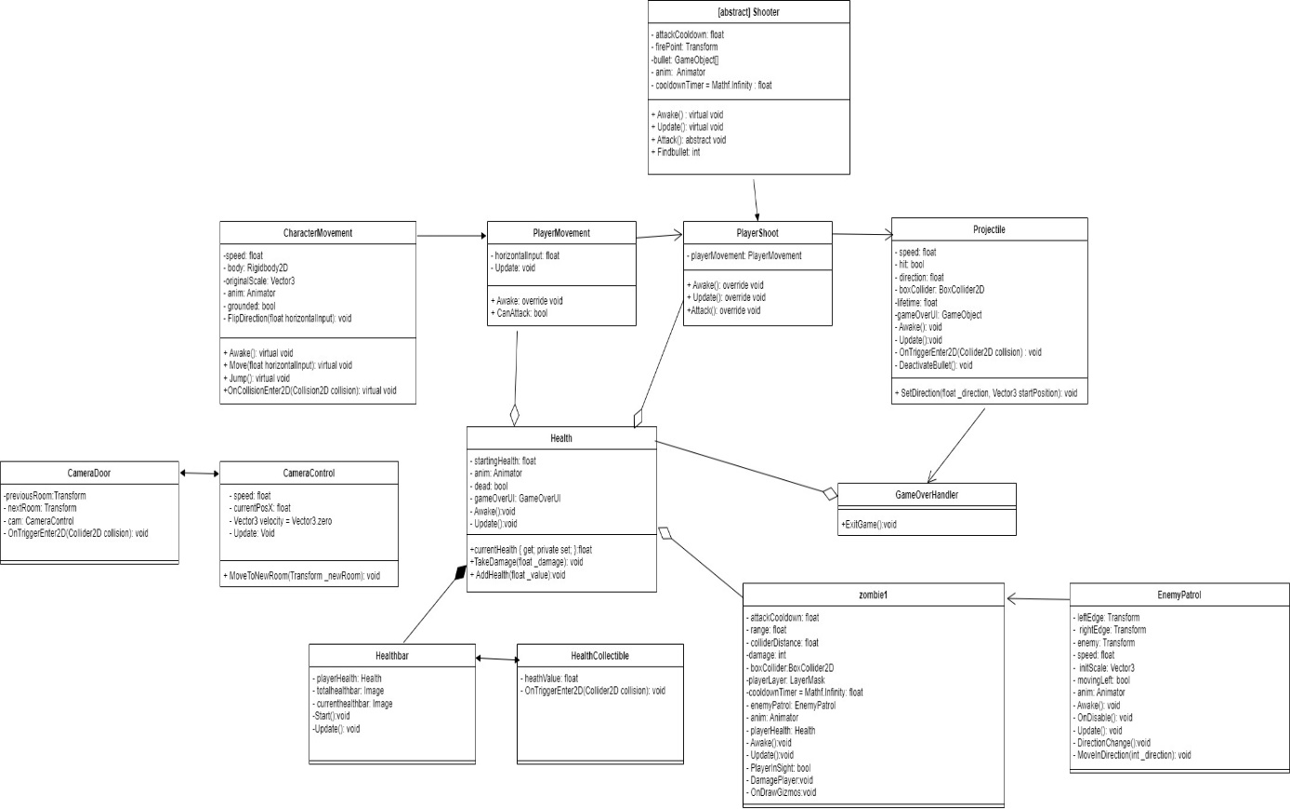

# Sequence Diagram